THE ASSETS ARE CREATED USING A BLENDER AND AND VIEWED USING MARKERS IN AN ANDROID APPLICATION.

THE CREATED ASSETS ARE:

1. SNOW MAN
2. SPINNING EARTH REVOLVING AROUND A SUN

THE MARKERS ARE :

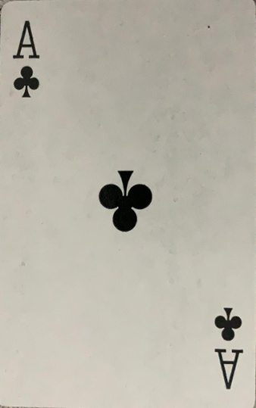 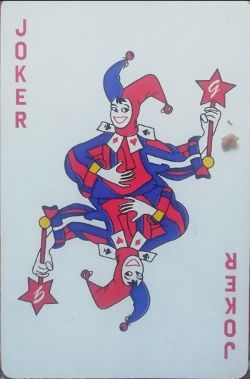

WHILE SCANNING THE MARKER1(ACE) ,THE SUN AND THE EARTH ARE VIEWED AND FOR THE MARKER2(JOKER) THE SNOWMAN IS VIEWED IN THE AR APP RESPECTIVELY.

